**Welcome to the Department of Computer Science & Business Systems**

Welcome to a department that blends the power of technology with the world of business. Here, you'll gain a strong foundation in computer science while also learning how to apply your technical skills to solve real-world business challenges.

The Computer Science & Business Systems program focuses on the integration of IT and business management. Students are equipped with the knowledge to design, develop, and implement technology solutions to support business operations, improve decision-making, and drive innovation. The curriculum covers core computer science subjects such as software development, databases, cybersecurity, and data analytics, while also providing insights into business management, marketing, finance, and operations.

Graduates of this program are prepared for careers in both technology and business, including roles such as business systems analyst, software developer, IT consultant, project manager, and data scientist. The combination of technical expertise and business acumen opens up a wide range of opportunities in industries such as IT consulting, finance, e-commerce, and enterprise software.

**VISION**

* To provide competent learning ecosystem to develop the understanding of technology and business to produce innovative, principled and insightful leaders to meet the societal demands.

**MISSION**

**Department of Computer Science and Business Systems shall,**

* To deliver high-quality education in the fields of technology and business through effective teaching-learning practices and a conducive learning environment.
* To create the center of excellence through collaborations with industries and various entities, addressing the evolving demands of society.
* To foster an environment that promotes innovation, multidisciplinary research, skill enhancement and entrepreneurship.
* To uphold and advocate for elevated standards of professional ethics and transparency.

**The Latest at Computer Science and Business Systems**

**News**

|  |  |
| --- | --- |
|  | **ONE DAY WORKSHOP ON CO, PO & MAPPING**  The Computer Science and Business Systems had organized One Day Workshop on "CO, PO and Mapping" for the teaching staff of KSSEM on 11/05/2024. Dr. K Senthil Babu, Professor and Head, Department of Electronics and Communication Engineering, KSSEM, and Dr. Abhishek R, Associate Professor, Department of Mechanical Engineering, KSSEM were the resource persons.  [View Image](https://kssem.edu.in/images/1715842772025_image.JPG) [View Report](https://kssem.edu.in/images/1715842772026_report.pdf) |

|  |  |
| --- | --- |
|  | **Innovation/Prototype Validation - Converting into Startup**  The Department of Computer Science and Business Systems, K. S. School of Engineering and Management organized a session on "Innovation/Prototype Validation - Converting Innovation into Start-up" on 29th August 2025 for 5th and 7th semester students. The session was delivered by Mr. Krishna Bhargav K L, Assistant Professor, Department of MBA, KSSEM, Bengaluru.  [View Image](https://kssem.edu.in/images/1757493331878_image.jpg) [View Report](https://kssem.edu.in/images/1757494018805_report.pdf) |

**Profile**

The Department of Computer Science and Business Systems is established with an intake of 60 in the year 2022. The Department offers 4 years of B.E program to promote excellence in producing Industry perspective professionals. This course is designed by TCS and has been approved by AICTE to provide Industry 4.0 ready professionals who add more value to the organization.

The students are also exposed to emerging topics such as Analytics, Deep learning, Machine Learning, Cloud Computing, Internet of Things and Design thinking to enable them for industry ready employability.

**Head Of The Department Desk**

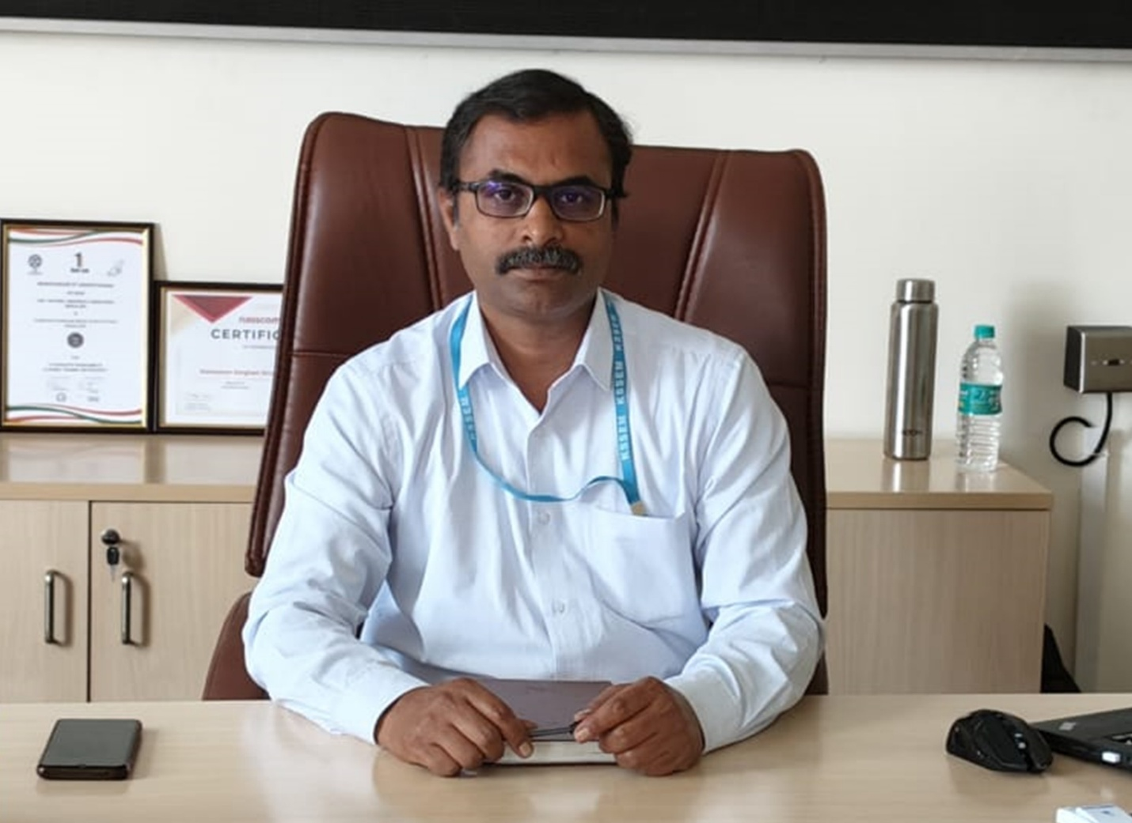

**Prof. Ramesh Babu. N**

**Assoc. Professor & Head**

**B.E, M.Tech, (Ph.D)**

It brings me great honour to welcome you to the Department of Computer Science and Business Systems.

Given the high demand for Computer Science professionals from the industry, the College has launched a new four undergraduate industry relevant Computer Science and Business Systems (CSBS) program powered by Tata Consultancy Services to address the growing need of engineering talent with managerial skills.

This curriculum aims to ensure that the students graduating from the program not only know the core topics of Computer Science but also develop an equal appreciation of Humanities, Management Sciences, and Human Values.

The students are also exposed to pursue Higher Studies in Reputed Universities Abroad and India with varied specializations and to become a successful Entrepreneur in the IT domain with Innovative Business Skills acquired through the competent curriculum designed by TCS.

**Highlights of Department**

* Active mentoring by Expert faculty members.
* Dual Course which includes Technical & Management Studies which is the need of the hour.
* Higher chances of placement as TCS have promised to prefer CSBS.
* Understanding Technology Abstraction
* Innovation Ability
* Strong in Ethics and Life Values

**Academic programs offered:**

**UG Program:**

Bachelor of Engineering (B.E.) in Computer Science and Business Systems (CS&BS) with approved intake of 60 students and a lateral entry of 20% from 2nd year.

**PROGRAM OUTCOMES**

**PO-1 :**

**Engineering Knowledge :** Apply the knowledge of mathematics, science, engineering fundamentals, and engg. specialization to the solution of complex engineering problems.

**PO-2 :**

**Problem Analysis :** Identify, formulate, research literature, and analyze engineering problems to arrive at substantiated conclusions using first principles of mathematics, natural, and engineering sciences.

**PO-3 :**

**Design/Development of solutions :** Design solutions for complex engineering problems and design system components, processes to meet the specifications with consideration for the public health and safety, and the cultural, societal, and environmental considerations.

**PO-4 :**

**Conduct Investigations of Complex problems :** Use research-based knowledge including design of experiments, analysis and interpretation of data, and synthesis of the information to provide valid conclusions.

**PO-5 :**

**Modern Tool Usage :** Create, select, and apply appropriate techniques, resources, and modern engineering and IT tools including prediction and modeling to complex engineering activities with an understanding of the limitations.

**PO-6 :**

**The Engineer and Society :** Apply reasoning informed by the contextual knowledge to assess societal, health, safety, legal, and cultural issues and the consequent responsibilities relevant to the professional engineering practice.

**PO-7 :**

**Environment and Sustainability :** Understand the impact of the professional engineering solutions in societal and environmental contexts, and demonstrate the knowledge of, and need for sustainable development.

**PO-8 :**

**Ethics :** Apply ethical principles and commit to professional ethics and responsibilities and norms of the engineering practice.

**PO-9 :**

**Individual and Team Work :** Function effectively as an individual, and as a member or leader in teams, and in multidisciplinary settings.

**PO-10 :**

**Communication :** Communicate effectively with the engineering community and with society at large. Be able to comprehend and write effective reports documentation. Make effective presentations, and give and receive clear instructions.

**PO-11 :**

**Project Management and Finance :** Demonstrate knowledge and understanding of engineering and management principles and apply these to one's own work, as a member and leader in a team. Manage projects in multidisciplinary environments.

**PO-12 :**

**Life-Long Learning :** Recognize the need for, and have the preparation and ability to engage in independent and life-long learning in the broadest context of technological change.

**PROGRAM EDUCATIONAL OBJECTIVES (PEOs)**

**Graduates of B.E. program in Computer Science and Business Systems will be able to :**

**PEO-1 :**

Pursue a prosperous professional journey in Information Technology and its related industries.

**PEO-2 :**

Creating innovative engineering solutions through continual learning, research and advanced problem-solving skills.

**Programme Specific Outcomes(PSOs)**

**PSO-1 :**

Comprehend fundamental and advanced concepts within the core domains of Computer Science to analyze, design and implement optimal solutions for real-world challenges.

**PSO-2 :**

Grasp business principles and employ the latest technologies to address business challenges effectively.

**Teaching And Learning**

The faculty of CS & BS department attends various MOOCS and training programs on advanced topics, updates their knowledge and skills, and gives additional inputs in the classes. Further, the faculty conducts various innovative teaching and learning activities to engage the students effectively and efficiently, which includes :

* Teaching with live demo sessions, working models, simulations and animated videos
* Assignments which include mini projects and case studies
* Conduction of online and classroom quizzes, surprise class tests, open book assignments, group discussions, seminars etc.
* Usage of ICT, Pupil pod and Google classrooms for posting assignments and lecture materials
* Usage of Google forms and Kahoot for online interaction, assessment and evaluation

**Instructional Materials**

The instructional materials are uploaded in Google Drive and are made available on institutional websites for student and faculty access.

**Faculty**

Faculty Details [[View Details]](https://kssem.edu.in/img/csbs/CSBS-stafflist-2025-26.pdf)

[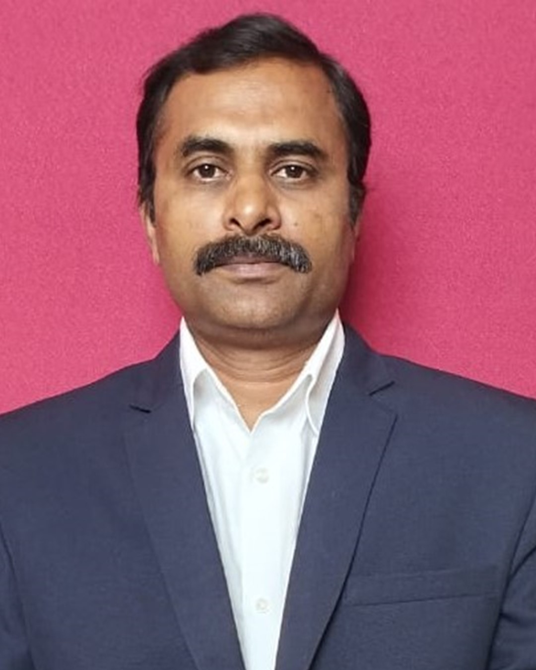](https://kssem.edu.in/images/1705916165729_image.jpg)

**Prof. Ramesh Babu. N**

**Associate Professor & Head**

BE, M.Tech, (Ph.D)

[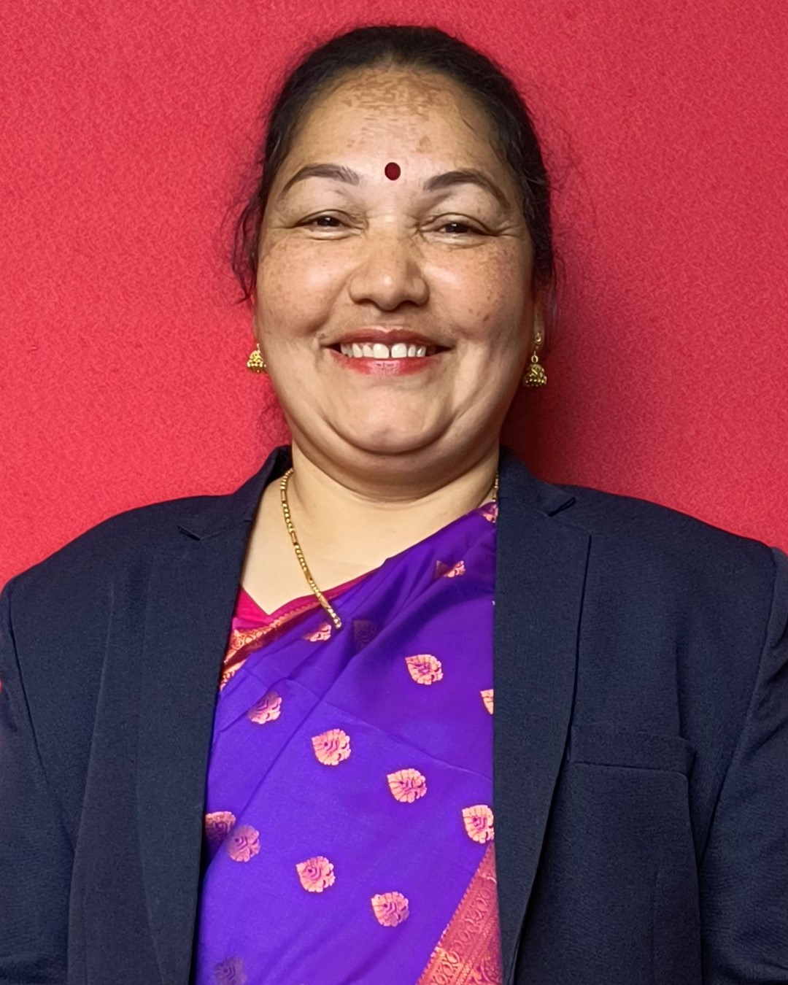](https://kssem.edu.in/images/1705917469954_image.jpg)

**Mrs. Jayashree. L. K**

**Associate Professor**

B.E, M.Tech, (PhD)

[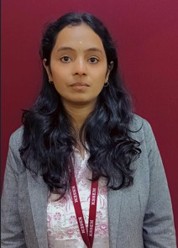](https://kssem.edu.in/images/2c9f8d418d2ca758018d309350b1000b_image.jpg)

**Mrs. NAYANA.H.P**

**Assistant Professor**

M.B.A(PH.D)

[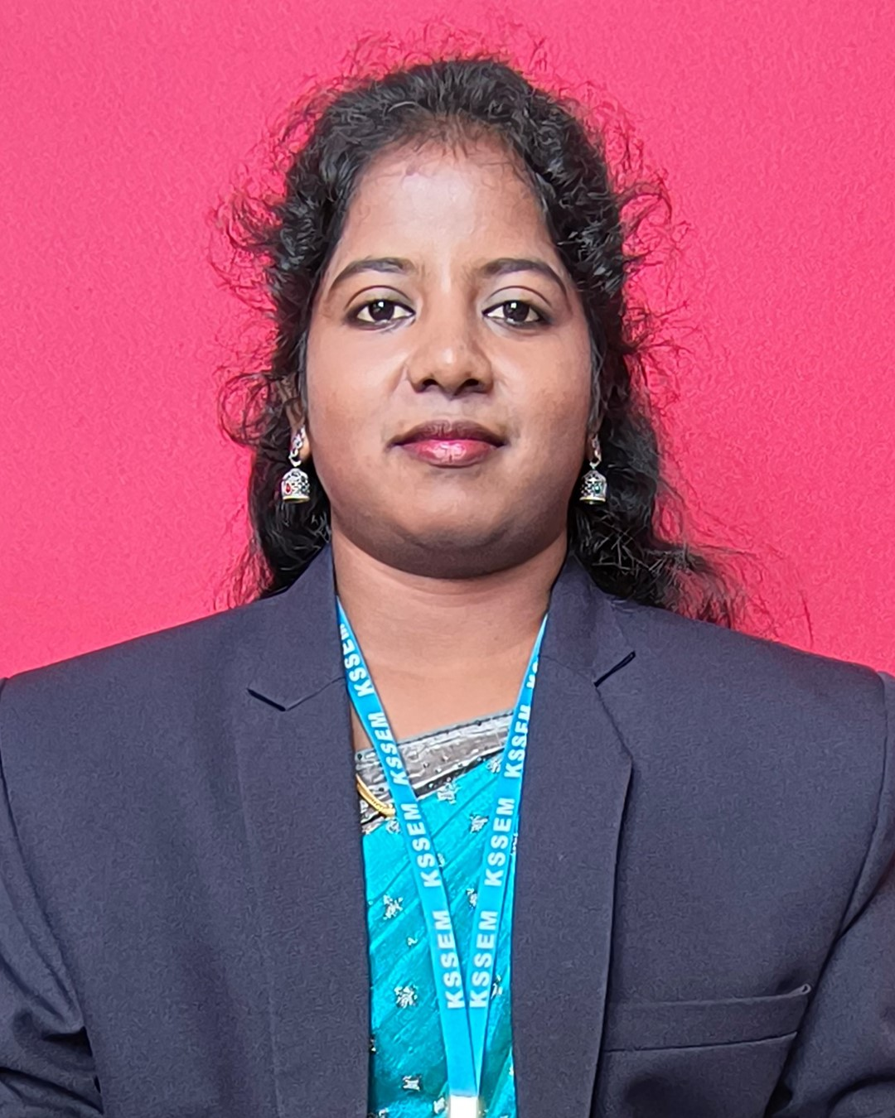](https://kssem.edu.in/images/1705917333429_image.jpg)

**Mrs. Frinkly Sathanga Shanija. T**

**Assistant Professor**

BE, M. Tech

[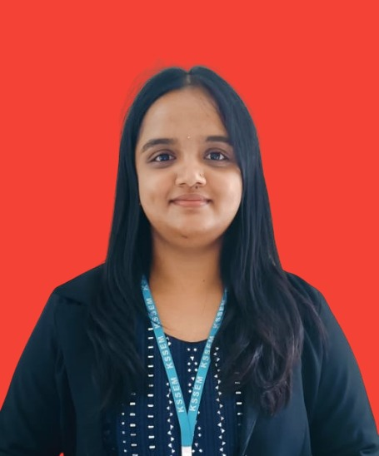](https://kssem.edu.in/images/2c9f858d9312592e01931a96fad50021_image.jpg)

**Ms. Kiranashree B K**

**Assistant Professor**

BE, M.Tech

[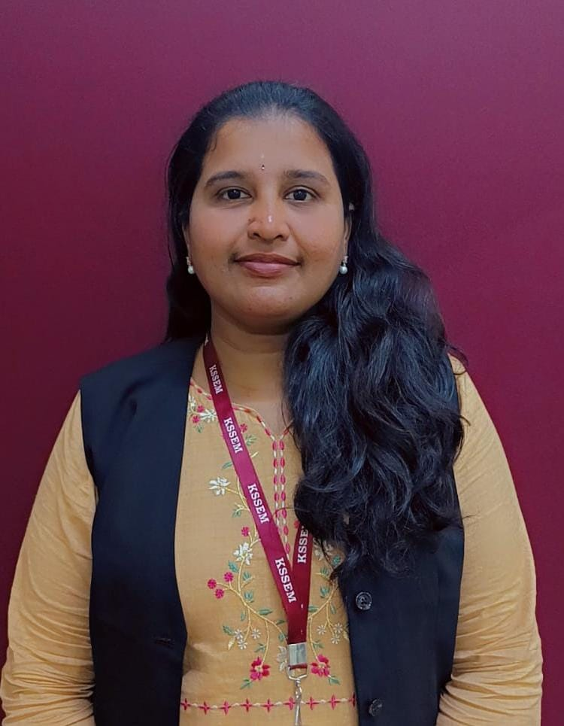](https://kssem.edu.in/images/2c9f858d990902e101990a1154100007_image.jpeg)

**Mrs. Seema Bawgi**

**Assistant Professor**

B.E, M.Tech

[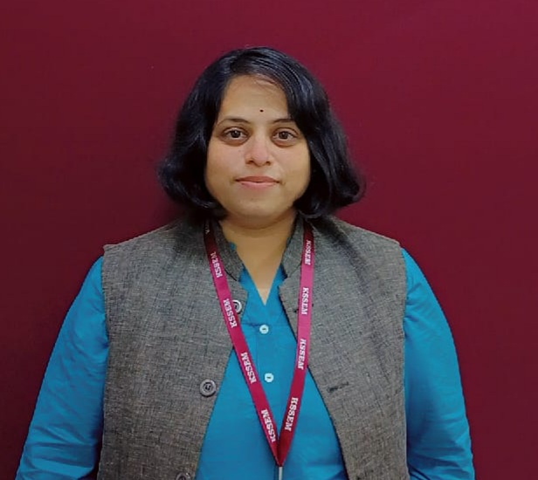](https://kssem.edu.in/images/2c9f858d9568c0960195697642f30001_image.jpg)

**Mrs.Lakshmi. V**

**Assistant Professor**

BE, M. Tech

[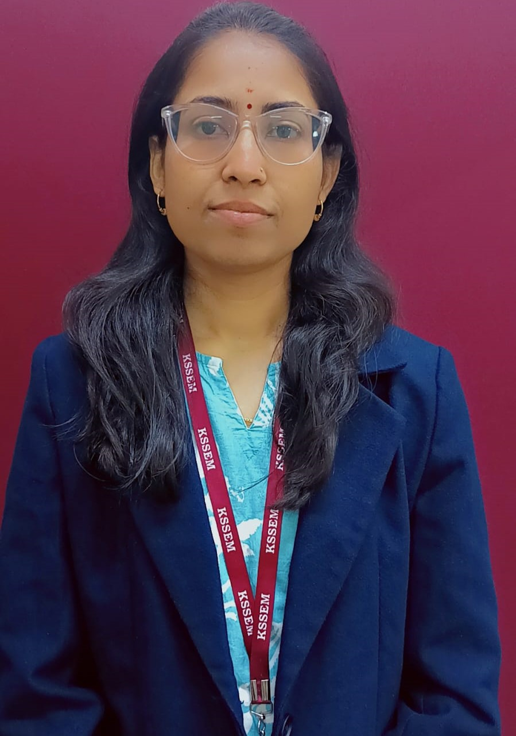](https://kssem.edu.in/images/2c9f858d990902e101990a13c8040008_image.jpeg)

**Mrs. SHUBHANGI**

**Assistant Professor**

B.E, M.Tech

[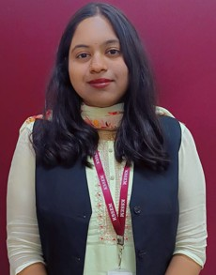](https://kssem.edu.in/images/2c9f858d99323df501993284f8da0001_image.jpg)

**Ms. HARINI KARAN**

**Assistant Professor**

B.E, M.Tech

[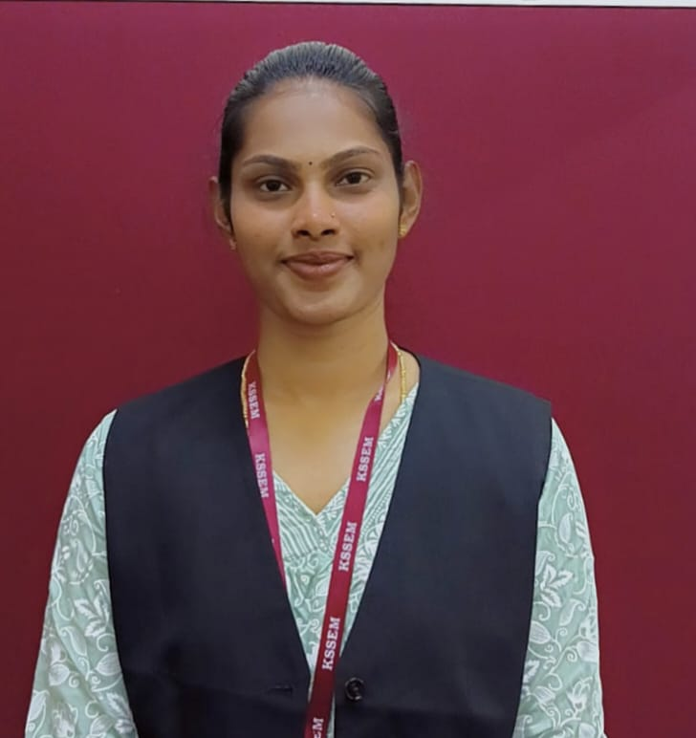](https://kssem.edu.in/images/1761818632697_image.jpeg)

**Mrs. Divyashree N**

**Assistant Professor**

B.E, M.Tech

**Supporting Faculty**

[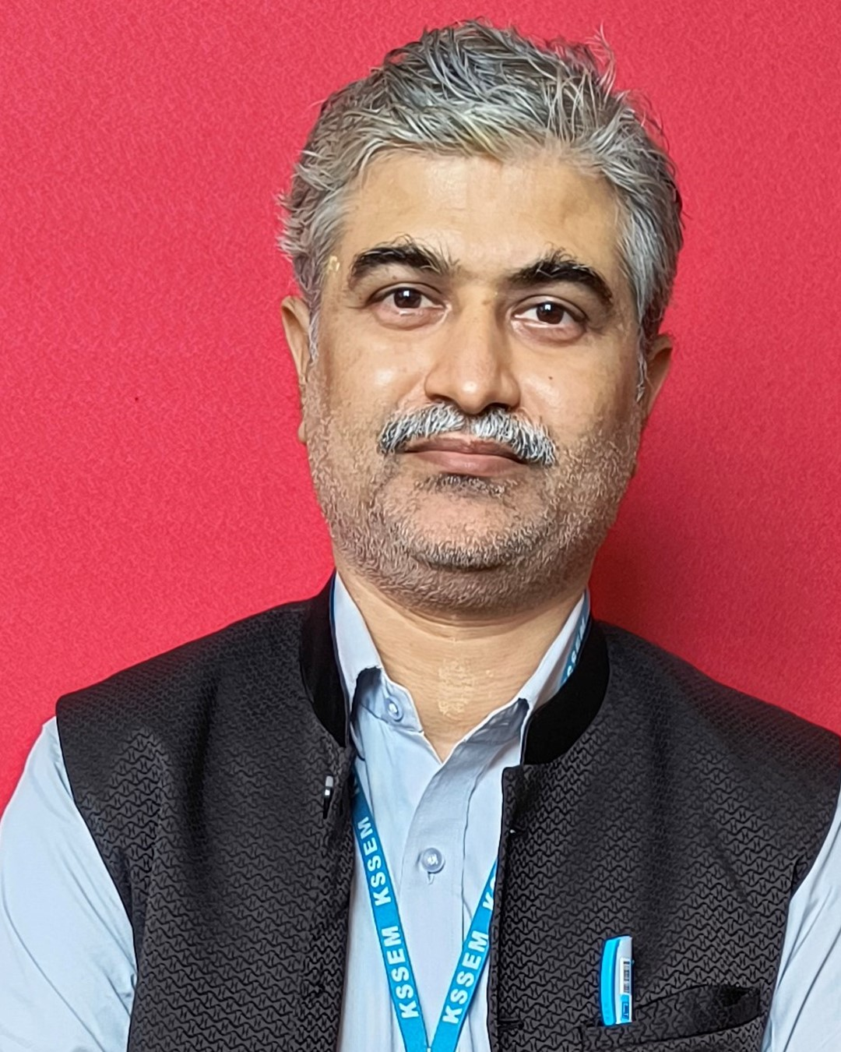](https://kssem.edu.in/images/1705930166502_image.jpg)

**Mr. Sreeranga P**

**Programmer**

B.E

[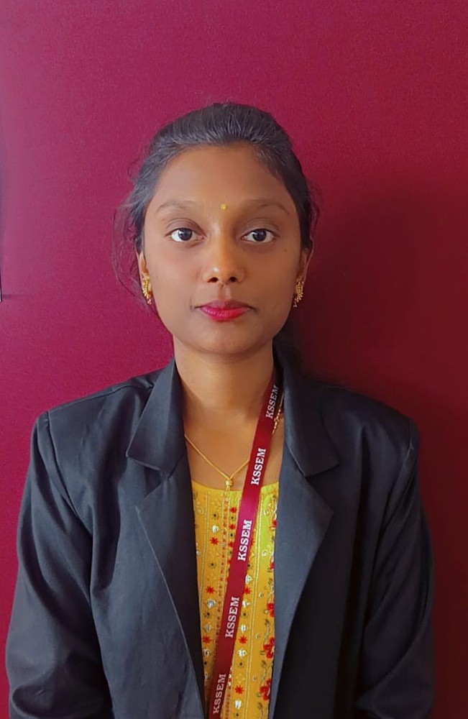](https://kssem.edu.in/images/2c9f858d9370115e0193712c2aa70005_image.jpg)

**Ms. Tejaswini S J**

**Programmer**

BCA

[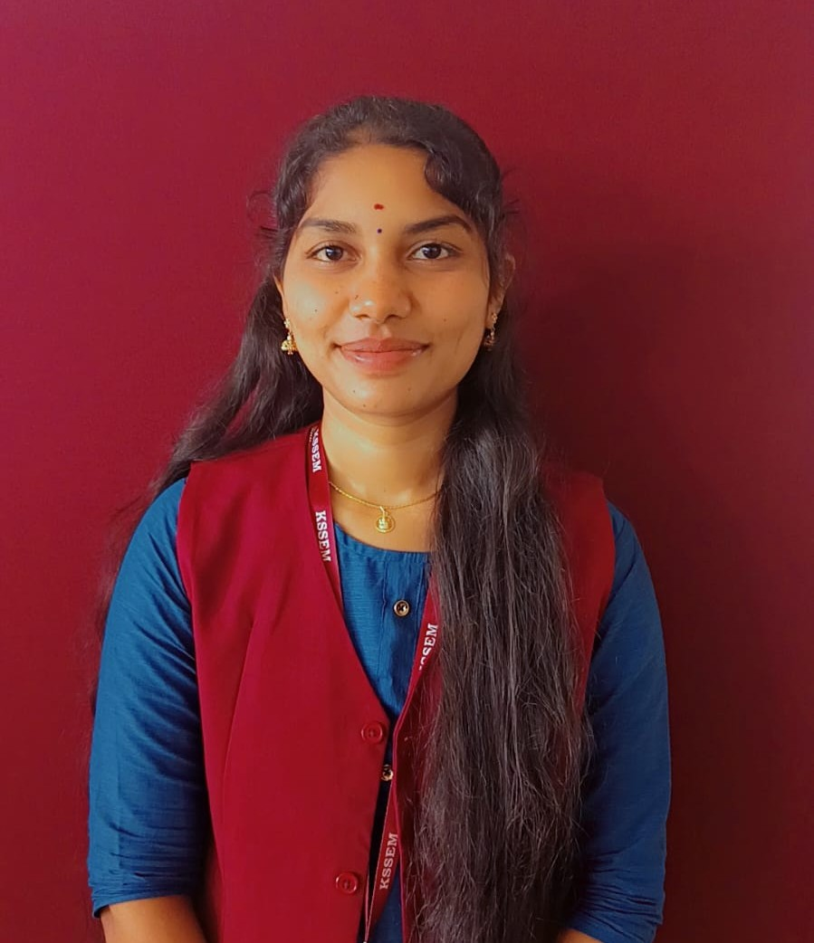](https://kssem.edu.in/images/2c9f858d990902e101990a17cf8a0009_image.jpg)

**Ms. V Manasa**

**Programmer**

B.Tech

[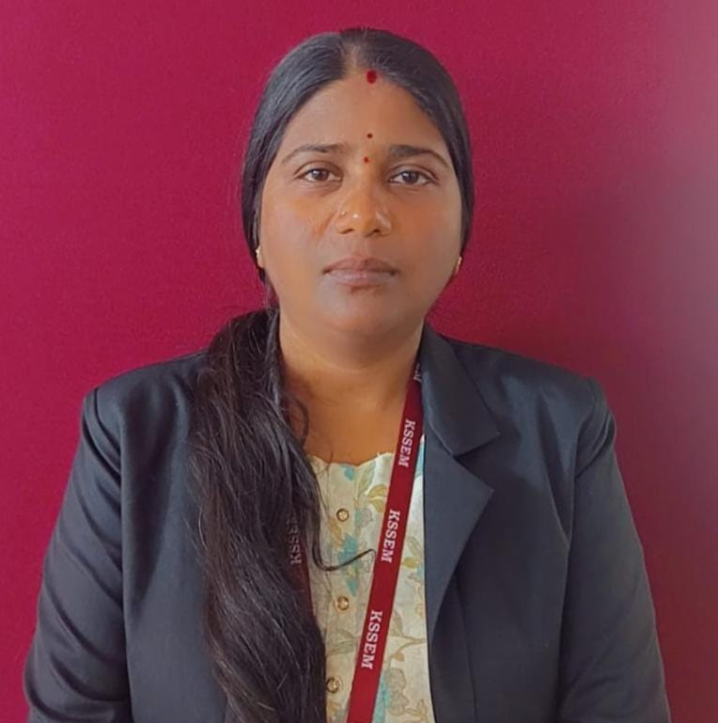](https://kssem.edu.in/images/2c9f858d990902e101990a19bea0000a_image.jpg)

**Mrs. Kaveri**

**FDA**

M.Com

[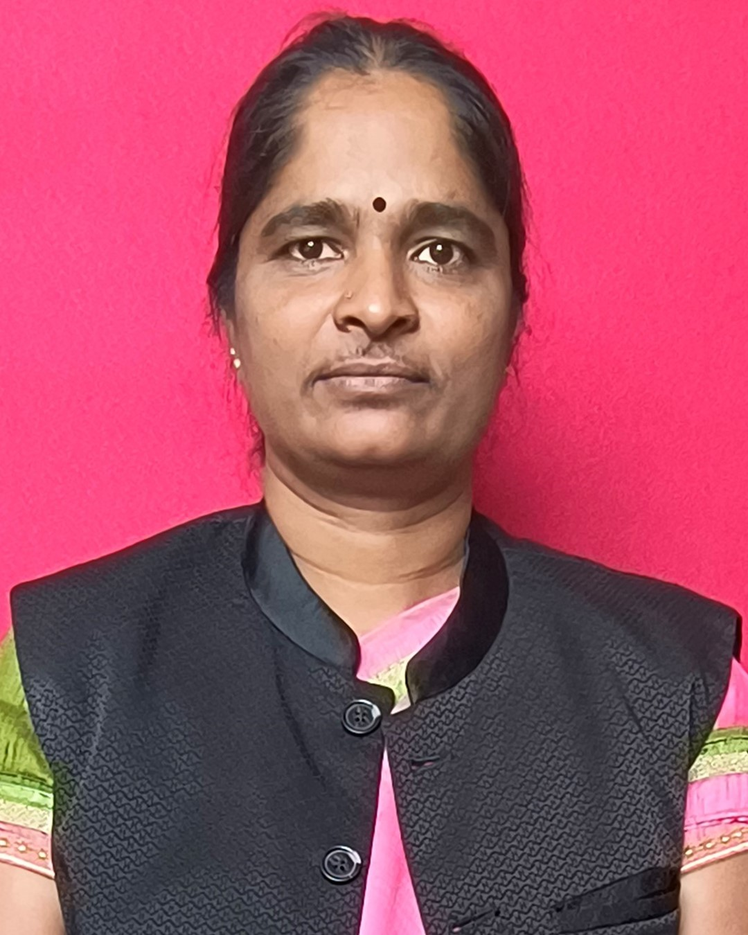](https://kssem.edu.in/images/1705930348603_image.jpg)

**Mrs. Lathashree G**

**Attender**

SSLC

[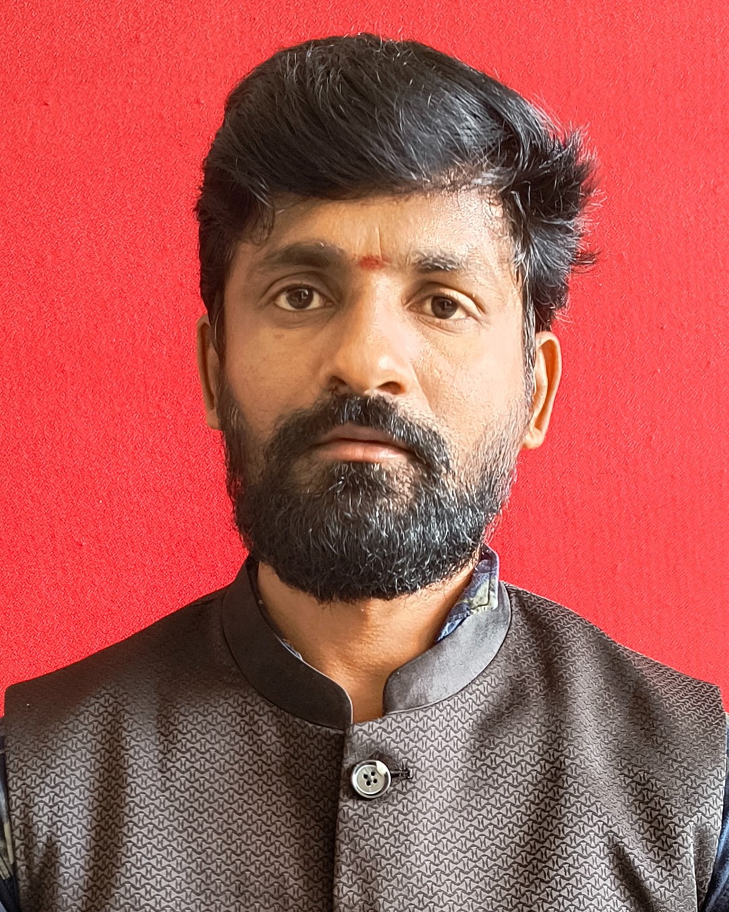](https://kssem.edu.in/images/1705930382774_image.jpg)

**Mr. Prabhu B K**

**Attender**

SSLC

**Department Achievers**

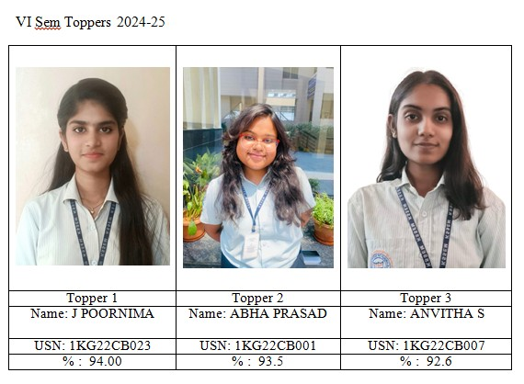

**VI Sem Toppers 2024-25**

2025-08-04

VI Sem TOP THREE ACHIEVERS 2024-25

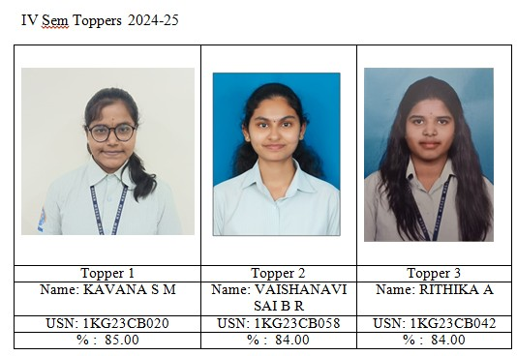

**IV Sem Toppers 2024-25**

2025-08-04

IV Sem TOP THREE ACHIEVERS 2024-25

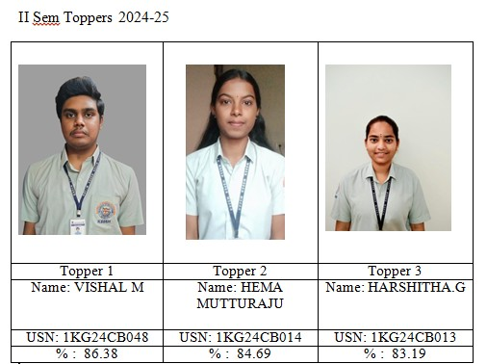

**II Sem Toppers 2024-25**

2025-09-09

II Sem TOP THREE ACHIEVERS 2024-25

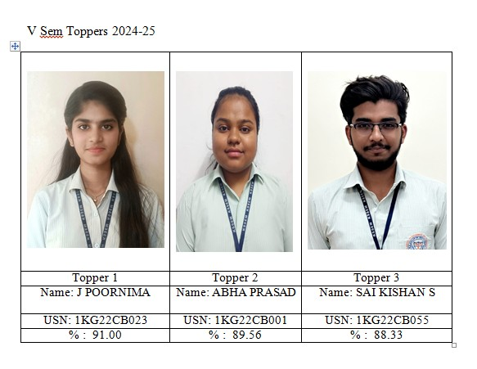

**V Sem Toppers 2024-25**

2025-02-24

V Sem TOP THREE ACHIEVERS 2024-25

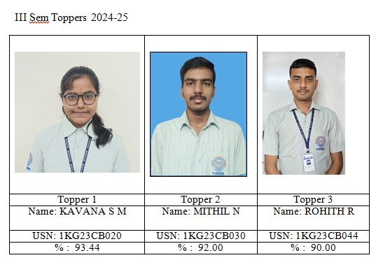

**III Sem Toppers 2024-25**

2025-03-07

III Sem TOP THREE ACHIEVERS 2024-25

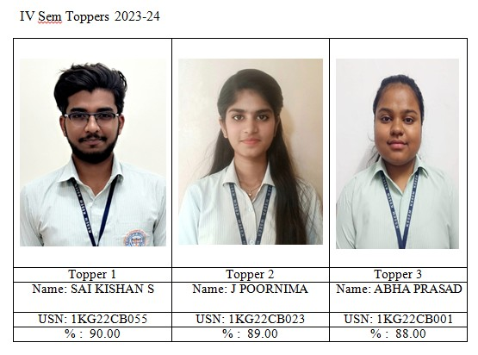

**IV SEM TOPPERS 2023-24**

2024-09-15

IV Sem TOP THREE ACHIEVERS 2023-24

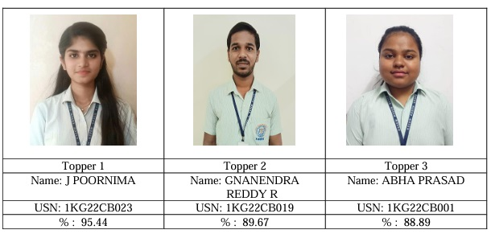

**3rd Sem TOPPERS**

2024-05-13

3rd SEM TOP THREE ACHIEVERS

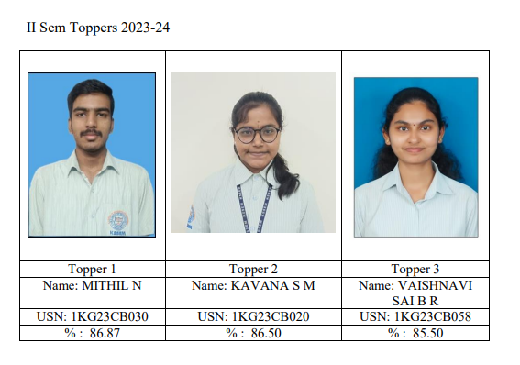

**2nd SEM TOPPERS**

2024-09-03

2nd SEM TOP THREE ACHIEVERS

[](https://kssem.edu.in/images/1757493785599_image.gif) [](https://kssem.edu.in/images/1758105751624_image.gif) [](https://kssem.edu.in/images/1752034837796_image.gif) [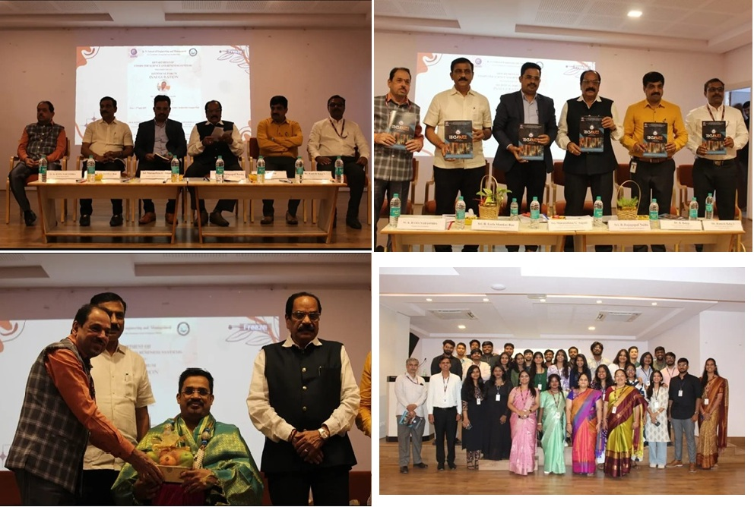](https://kssem.edu.in/images/1757921279069_image.jpg) [](https://kssem.edu.in/images/1753941420935_image.gif) [](https://kssem.edu.in/images/1742441762640_image.gif) [](https://kssem.edu.in/images/1744017178761_image.gif) [](https://kssem.edu.in/images/1742549064281_image.gif) [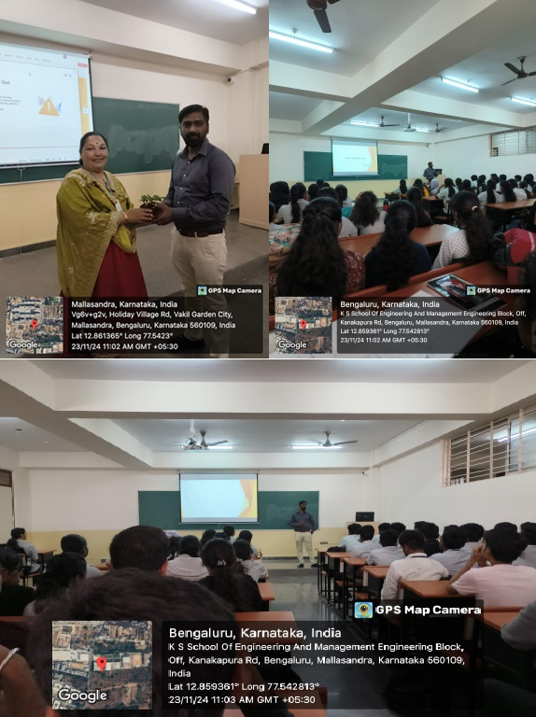](https://kssem.edu.in/images/1733116612092_image.jpg) [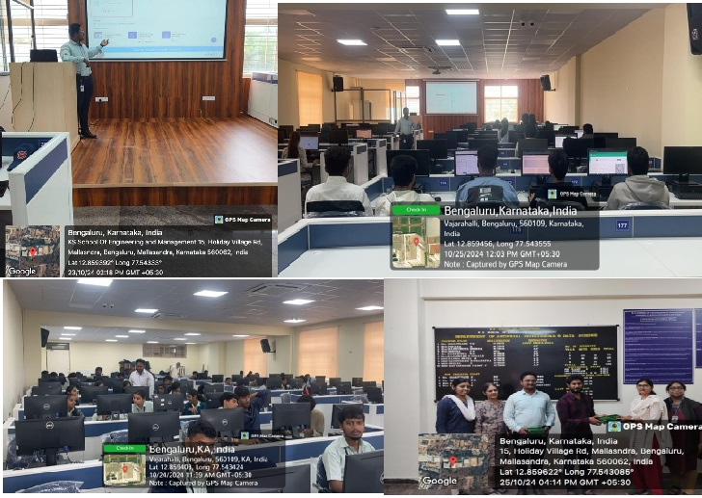](https://kssem.edu.in/images/1732266155554_image.jpg) [](https://kssem.edu.in/images/1729849045909_image.gif) [](https://kssem.edu.in/images/1729848325395_image.gif) [](https://kssem.edu.in/images/1720155784808_image.gif) [](https://kssem.edu.in/images/1720155742817_image.gif) [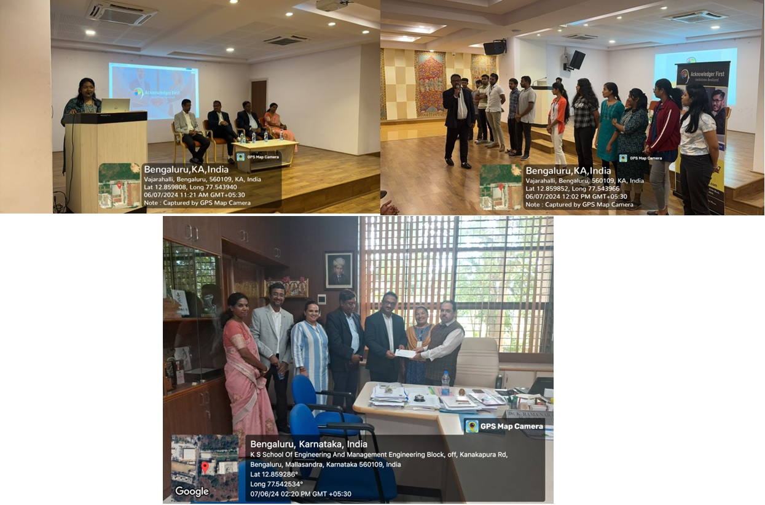](https://kssem.edu.in/images/1718273672854_image.jpg) [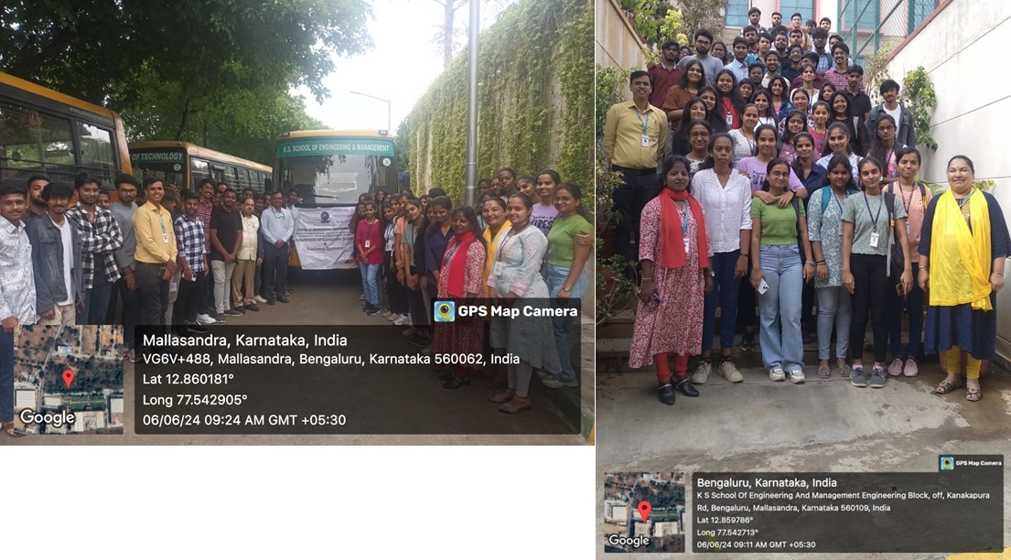](https://kssem.edu.in/images/1718273089758_image.jpg) [](https://kssem.edu.in/images/1718099783792_image.gif) [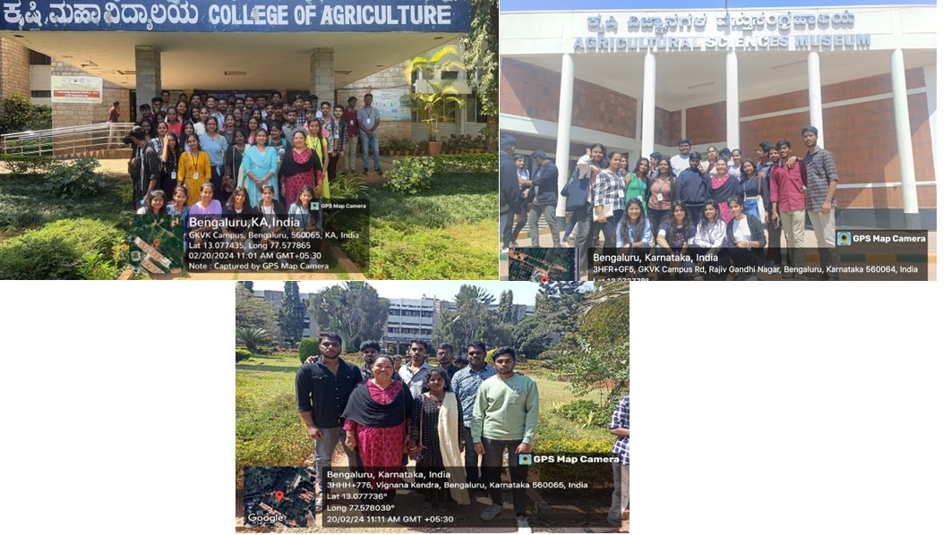](https://kssem.edu.in/images/1712131550661_image.jpg) [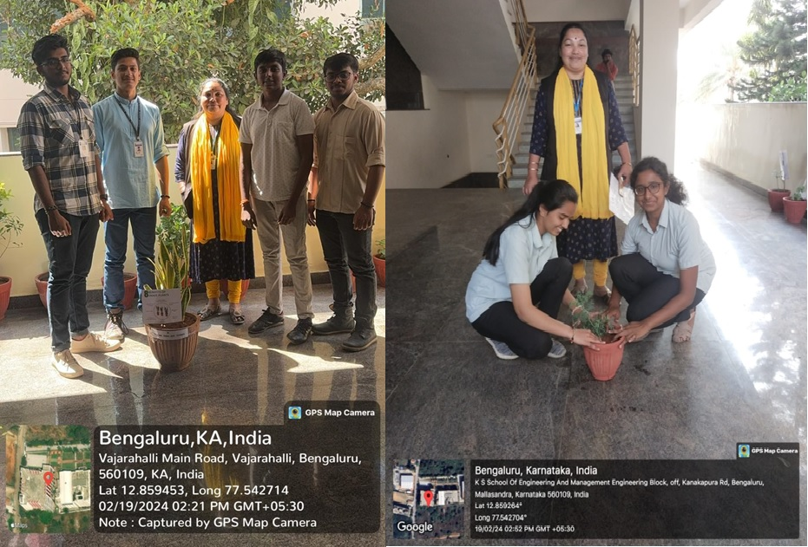](https://kssem.edu.in/images/1714629986758_image.jpg) [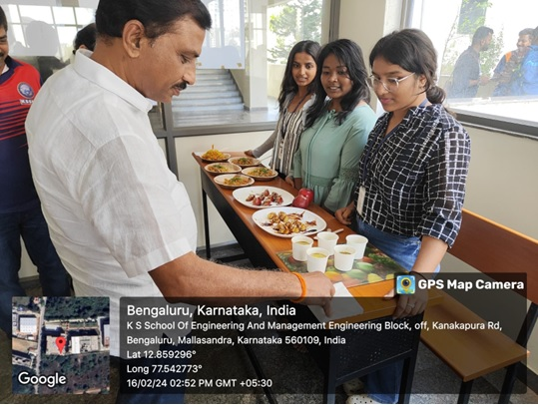](https://kssem.edu.in/images/1712131266386_image.jpg) [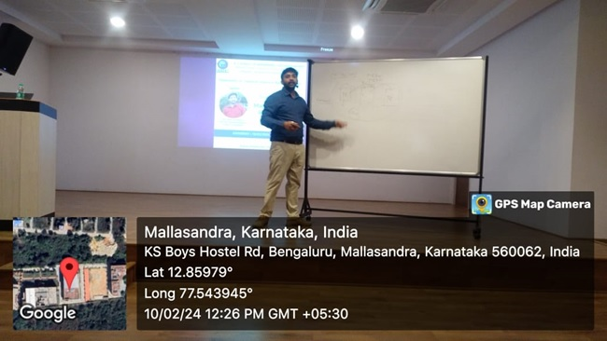](https://kssem.edu.in/images/1712131215606_image.jpg) [](https://kssem.edu.in/images/1712214025317_image.gif) [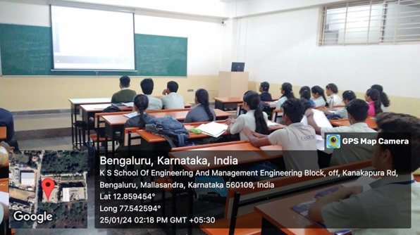](https://kssem.edu.in/images/1712131055018_image.jpg) [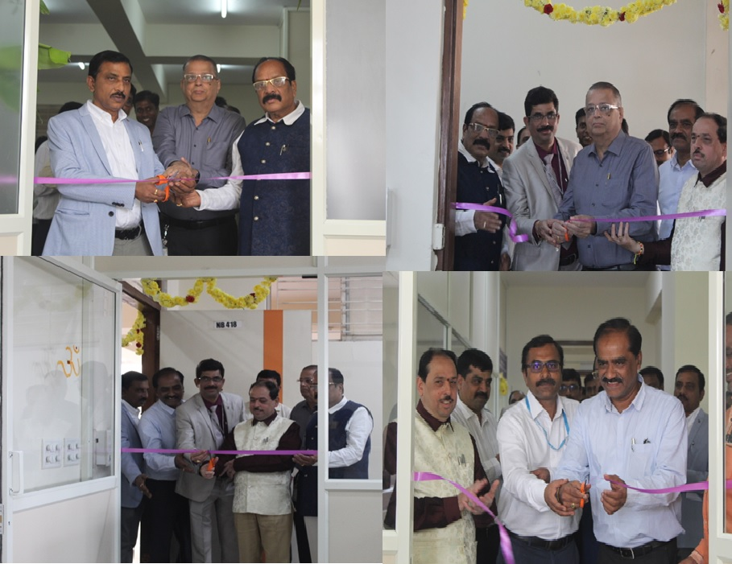](https://kssem.edu.in/images/1712130901193_image.jpg) [[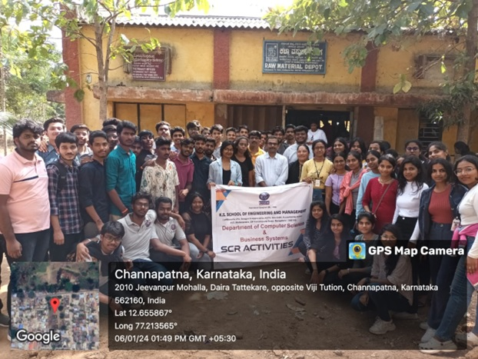](https://kssem.edu.in/images/1712131003058_image.jpg)**Heritage Walk**](https://kssem.edu.in/images/1712131003058_image.jpg)

[](https://kssem.edu.in/images/1757493785599_image.gif) [](https://kssem.edu.in/images/1758105751624_image.gif) [](https://kssem.edu.in/images/1752034837796_image.gif) [](https://kssem.edu.in/images/1757921279069_image.jpg) [](https://kssem.edu.in/images/1753941420935_image.gif) [](https://kssem.edu.in/images/1742441762640_image.gif) [](https://kssem.edu.in/images/1744017178761_image.gif) [](https://kssem.edu.in/images/1742549064281_image.gif) [](https://kssem.edu.in/images/1733116612092_image.jpg) [](https://kssem.edu.in/images/1732266155554_image.jpg) [](https://kssem.edu.in/images/1729849045909_image.gif) [](https://kssem.edu.in/images/1729848325395_image.gif) [](https://kssem.edu.in/images/1720155784808_image.gif) [](https://kssem.edu.in/images/1720155742817_image.gif) [](https://kssem.edu.in/images/1718273672854_image.jpg) [](https://kssem.edu.in/images/1718273089758_image.jpg) [](https://kssem.edu.in/images/1718099783792_image.gif) [](https://kssem.edu.in/images/1712131550661_image.jpg) [](https://kssem.edu.in/images/1714629986758_image.jpg) [](https://kssem.edu.in/images/1712131266386_image.jpg) [](https://kssem.edu.in/images/1712131215606_image.jpg) [](https://kssem.edu.in/images/1712214025317_image.gif) [](https://kssem.edu.in/images/1712131055018_image.jpg) [](https://kssem.edu.in/images/1712130901193_image.jpg) [[](https://kssem.edu.in/images/1712131003058_image.jpg)**Heritage Walk**](https://kssem.edu.in/images/1712131003058_image.jpg)

**Higher Education**

**The department conduct higher studies awareness program in order to motivate the students to do higher studies both within the country and abroad. The department in association with training and placement department helps students in understanding the importance of attempting various competitive exams like GATE, IELTS, GRE, TOEFL etc.**

**High-end Master's programs are: M.S, M.Tech, or M.E. in :**

* **Artificial intelligence**
* **Data Science**
* **Machine Learning**
* **Embedded systems**
* **Knowledge-based systems**
* **Bio-informatics**
* **Software Engineering**
* **Systems Engineering.**
* **Distributed Computing**
* **Image Processing**
* **Information Security**
* **Cyber Security**

**Computer Science & Engineering Department Forum**

**ENCRYPTONITES**

The association was inaugurated by President Sri Subramanyam Naidu, Hon. Secretary Sri S. R. Naidu, Principal/Director Dr. S.N.Sridhara, Chief Guests Mr. R. K. Shanthikiran, Engineering Manager, CISCO and Mr. Anantha Padmanabha Naidu, AGM, HCL Technologies. Chief Guests had inspired the students saying "Learning never ends".

**Main Objective of Forum :**

* Bringing in high level of interaction between the students and Resource experts and to organize technical sessions, workshops through a close tie-up with the Industry.
* **Internships**
* Internships are foundational in preparing students for the workforce and providing opportunities after graduation. Most employers seek career-ready college graduates who have been equipped with prior experiences and skills in a given field. An internship is important because it can present you with new skills and opportunities that student would not receive otherwise. Interns not only gain technical knowledge within the industry of their choice, but they also learn how to interact with professionals in a workplace setting, and develop essential soft skills like time management, organization, adaptability, problem-solving and teamwork. An internship is the best way to gain work experience as a student. Internships give you the valuable practical experience needed along with theoretical knowledge. Employers often note that there is a disconnect between the requirements of the industry and the academics. This gap can be bridged by an internship and pitch you as an ideal candidate.
* **Projects**
* Final year project is one of the most important aspects of Engineering degree. Final year project will be the first exposure to the full rigour of Engineering practice. It is essential that students learn from this exposure and practise all of the engineering methodologies involved. It is particularly important that students learn not just to apply what they know, but to apply it with judgement.
* **Mini-Projects**
* Mini projects for engineering students give an edge over the race of recruitment to work hard to ensure a good career. By taking up mini projects, students can gain practical knowledge. The technical skills can only be improved by taking up mini projects. Students become more productive.
* **ndustrial Visit**
* Objectives of industrial visit is to provide students an insight regarding internal working of companies. Students know, theoretical knowledge which is not enough for making a good professional career. With an aim to go beyond academics, the department conducts industrial visit provides student a practical perspective on the world of work. The department also provides the visit to premier institutions like IISc and IIIT during Open Day and Open House respective events to give students awareness to newer technologies that help them in deciding the project topics during their final year.
* 
* **INDUSTRIAL VISIT TO ISRO**
* INDUSTRIAL VISIT TO ISRO
* **Events**
* 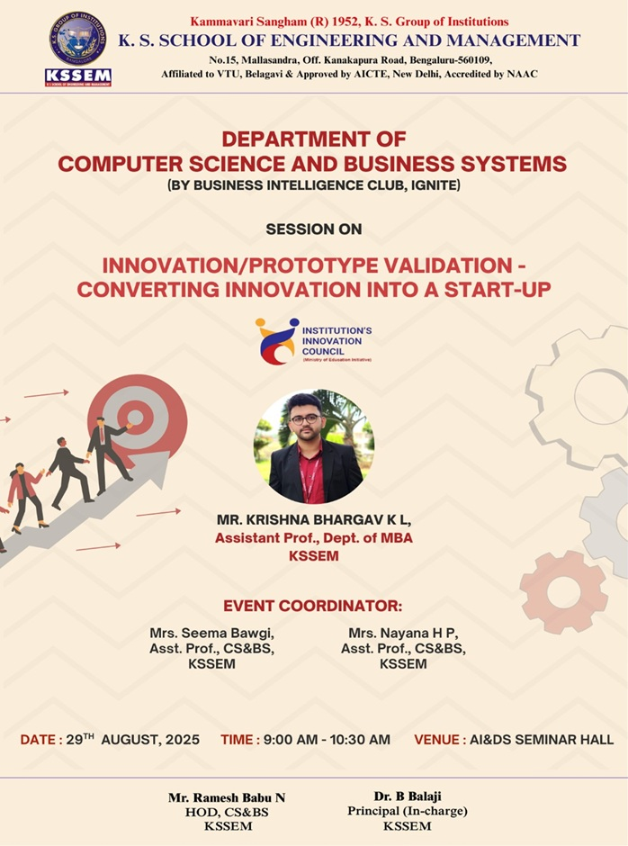
* **Innovation/Prototype Validation - Converting into Startup**
* "The Department of Computer Science and Business Systems, K. S. School of Engineering and Management organized a session on "Innovation/Prototype Validation - Converting Innovation into Start-up" on 29th August 2025 for 5th and 7th semester students. The session was delivered by Mr. Krishna Bhargav K L, Assistant Professor, Department of MBA, KSSEM, Bengaluru."
* 2025-08-29
* 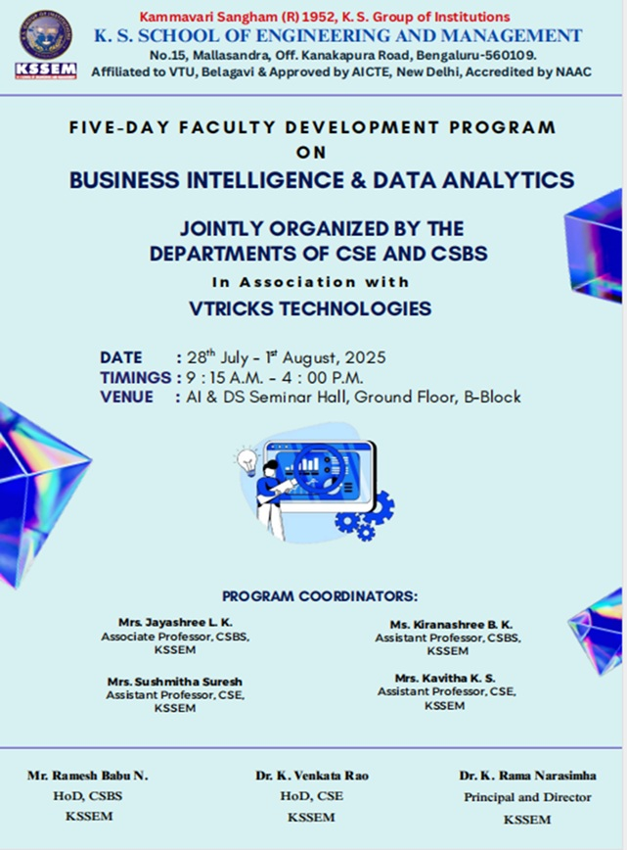
* **FDP on BUSINESS INTELLIGENCE & DATA ANALYTICS**
* "FIVE - DAY FACULTY DEVELOPMENT PROGRAM on BUSINESS INTELLIGENCE & DATA ANALYTICS, JOINTLY ORGANIZED BY THE DEPARTMENTS OF CSE AND CSBS DATE: 28 July - 1 August, 2025"
* 2025-08-28
* 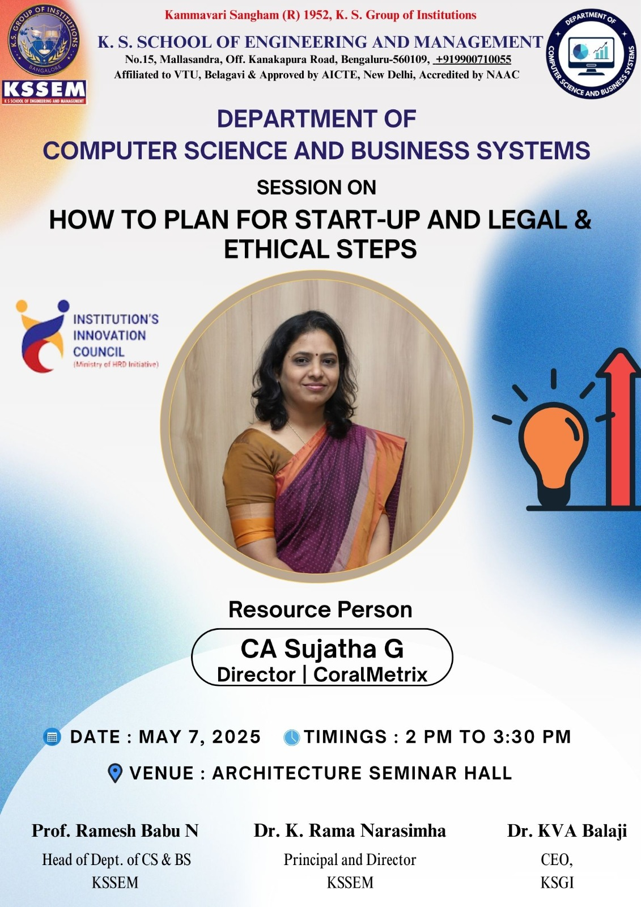
* **How to Plan for Start-Up and Legal & Ethical Steps**
* "The Department of Computer Science and Business Systems, K. S. School of Engineering and Management organized a session on "How to Plan for Start-Up and Legal & Ethical Steps" on 7th March 2025 for 4th and 6th semester students. The sessions were delivered by Mrs. Sujatha G, Director, CoralMetrix Bengaluru. "
* 2025-05-07
* 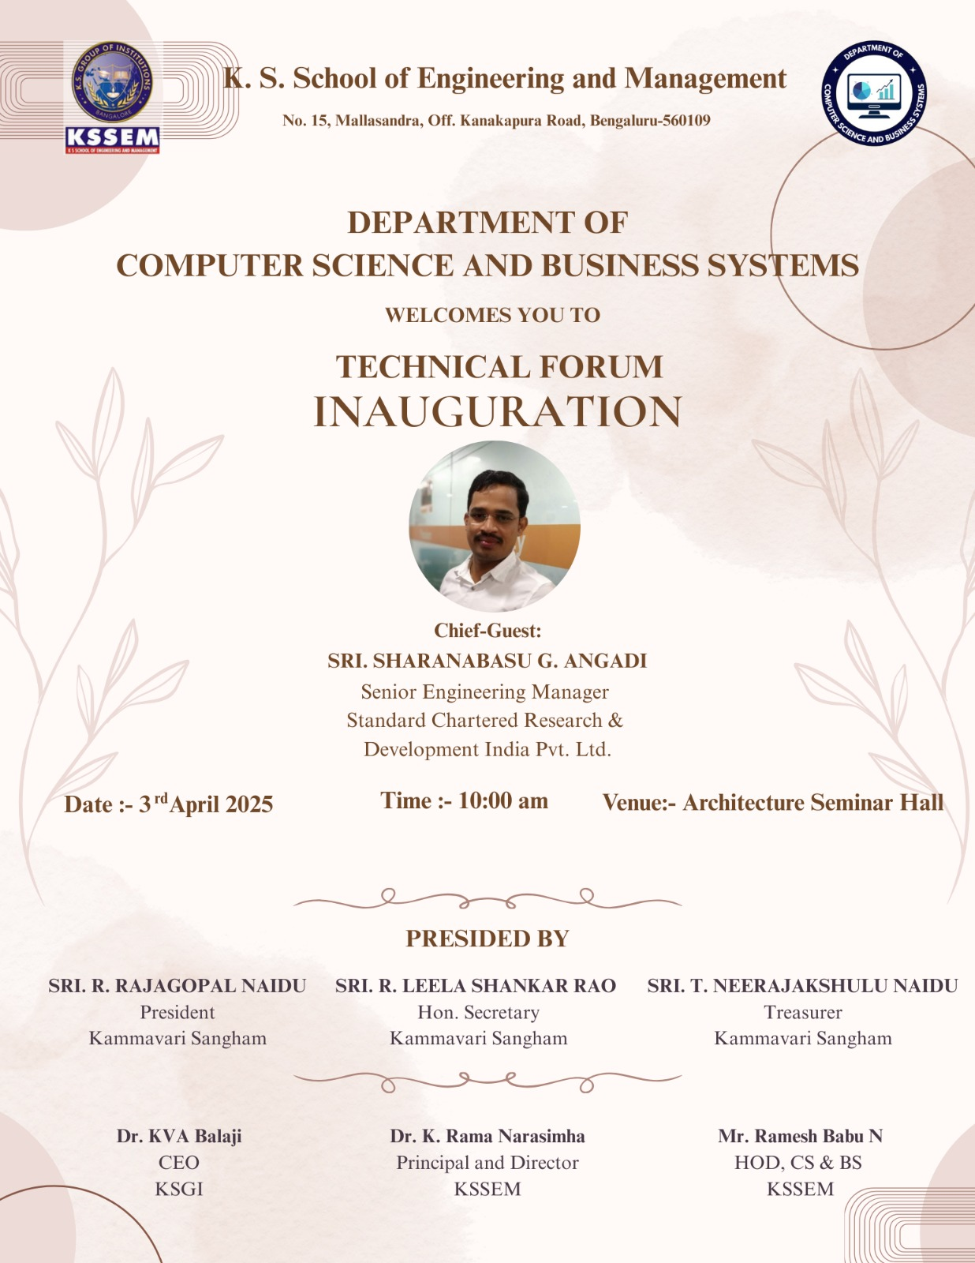
* **Technical Forum Inauguration**
* "The Department of Computer Science and Business Systems (CSBS), KSSEM, organized the inauguration ceremony of the IGNITE Technical Forum on 3rd April 2025. The event marked the formal launch of the forum, alongside the unveiling of the department newsletter and logo. It served as a platform to promote student-led technical initiatives, innovation, and collaborative growth. The event featured participation from institutional management, faculty, students, and an esteemed industry guest."
* 2025-04-03
* 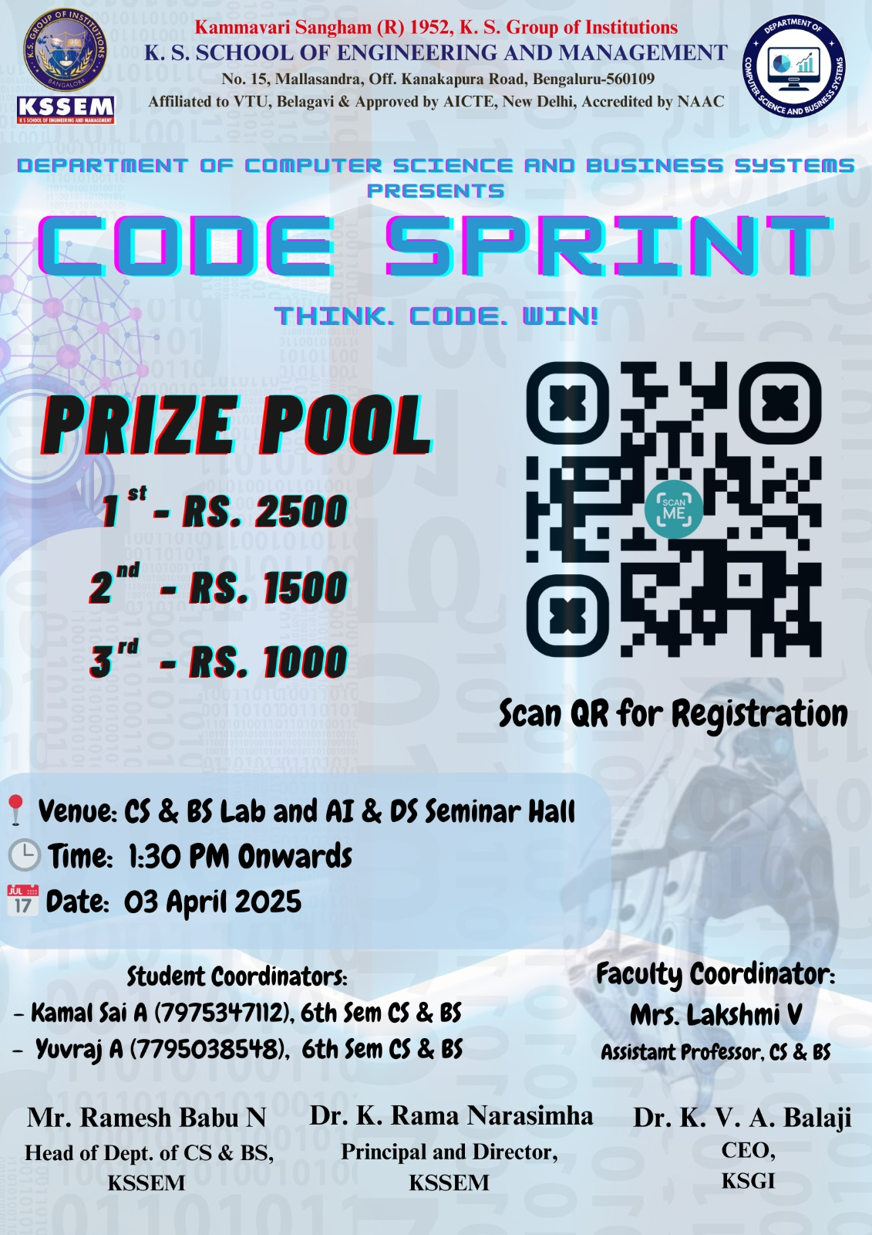
* **CODING COMPETITION "CODE SPRINT"**
* "The Department of Computer Science and Business Systems, K. S. School of Engineering and Management organized a Coding Competition- "CODE SPRINT" on 3rd April 2025 for students at college level in offline mode. The Competition was attended by 67 participants."
* 2025-04-03
* 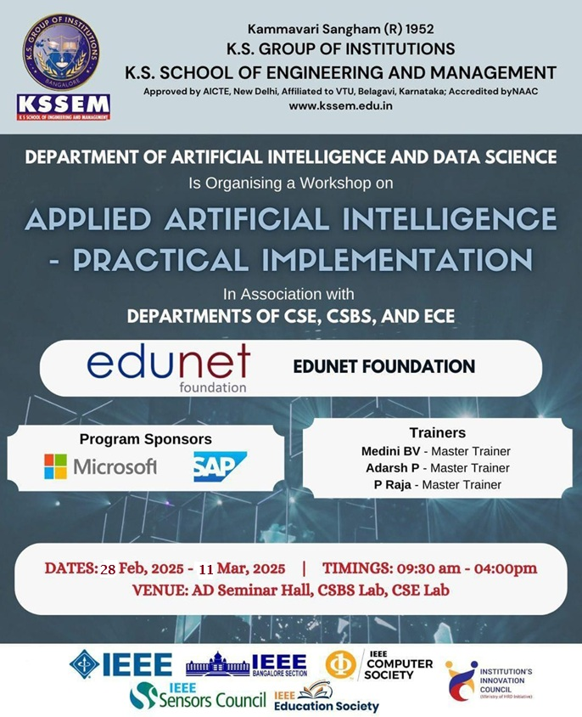
* **Applied Artificial Intelligence - Practical Implementations**
* "The Department of Computer Science and Business Systems, KS School of Engineering and Management organized 10 Day Workshop on "Applied Artificial Intelligence -Practical Implementation" on 28th February 2025 to 11th March 2025 for 6th Semester students. The workshop was jointly organized with department of AI & DS, CSE & ECE. It was organized in association with Edunet Foundation and was sponsored by Microsoft and SAP. The sessions were delivered by Mr. Aditya."
* 2025-03-11
* 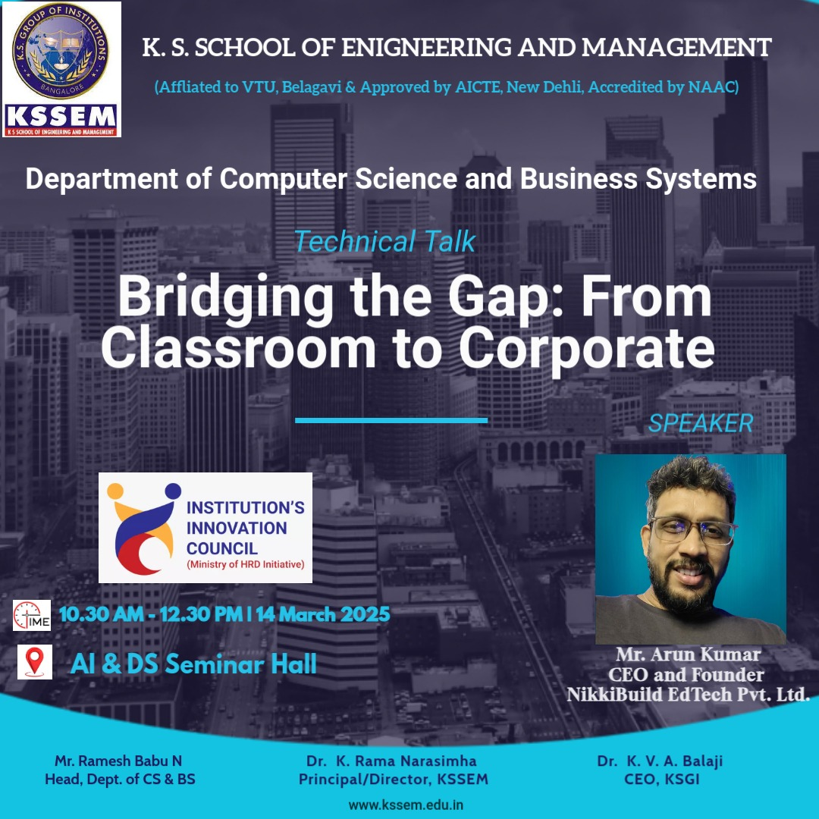
* **"Bridging the Gap: From Classroom to Corporate"**
* "The Department of Computer Science and Business Systems, KS School of Engineering and Management organized a technical talk on "Bridging the Gap: From Classroom to Corporate" on 14th March 2025 for 4th and 6th semester students. The sessions were delivered by Mr. Arun Kumar, Founder and CEO, NikkiBuild EdTech Pvt. Ltd. Bengaluru"
* 2025-03-14
* 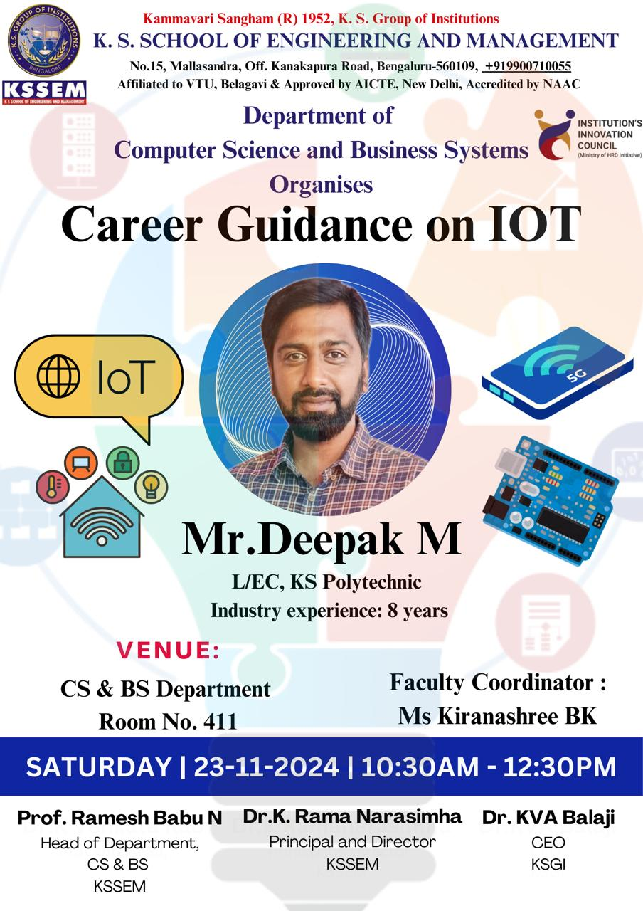
* **Career Guidance on IOT**
* "The Department of Computer Science and Business Systems, KS School of Engineering and Management, organized a technical talk titled "Career Guidance in IoT" on 23rd November 2024 for 3rd semester students. The session was delivered by Mr. Deepak M, Lecturer, KS Polytechnic, who shared valuable insights into career opportunities, industry trends and essential skills related to the Internet of Things (IoT)."
* 2024-11-23
* 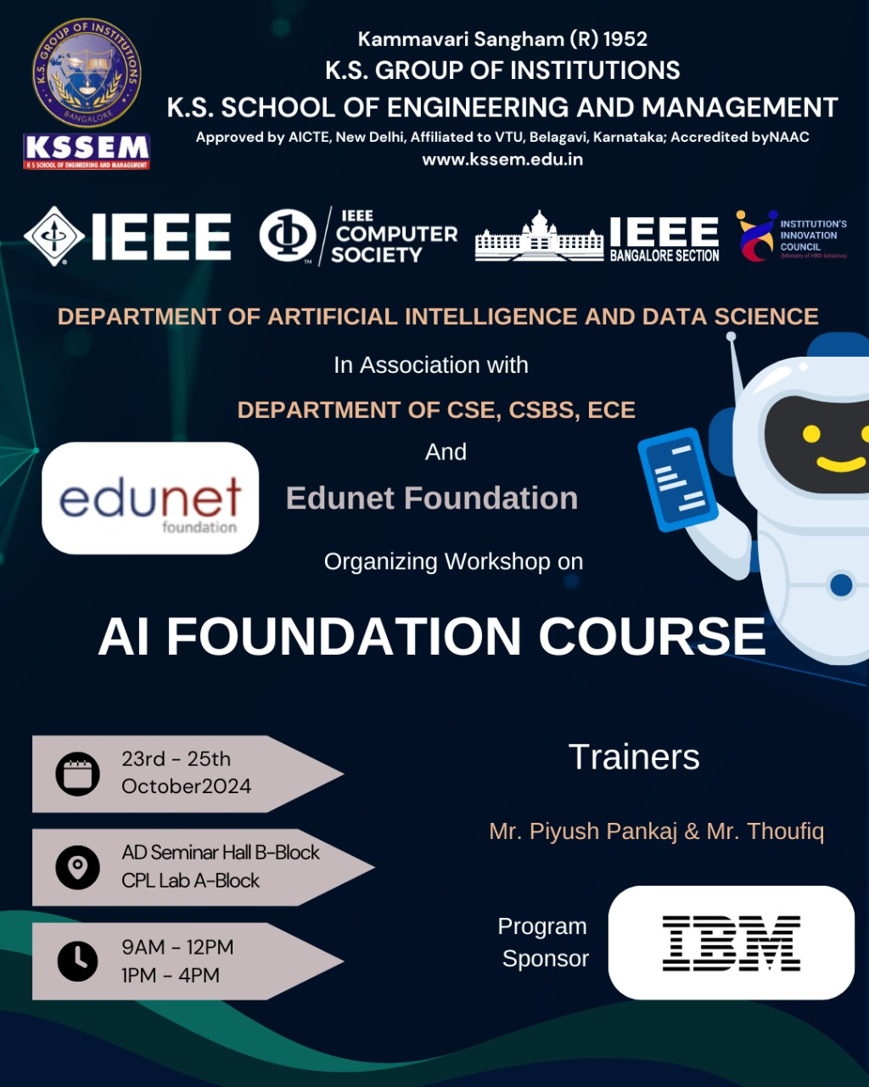
* **AI FOUNDATION COURSE**
* "The Department of Computer Science and Business Systems, KS School of Engineering and Management organized 3 Day Workshop on "AI foundation Course" on 23rd October 2024 to 25th October 2024 for 3rd students. The workshop was jointly organized with department of AI & DS, CSE & ECE. It was organized in association with Edunet Foundation and was sponsored by IBM. The sessions were delivered by Mr. Piyush Pankaj."
* 2024-10-23
* 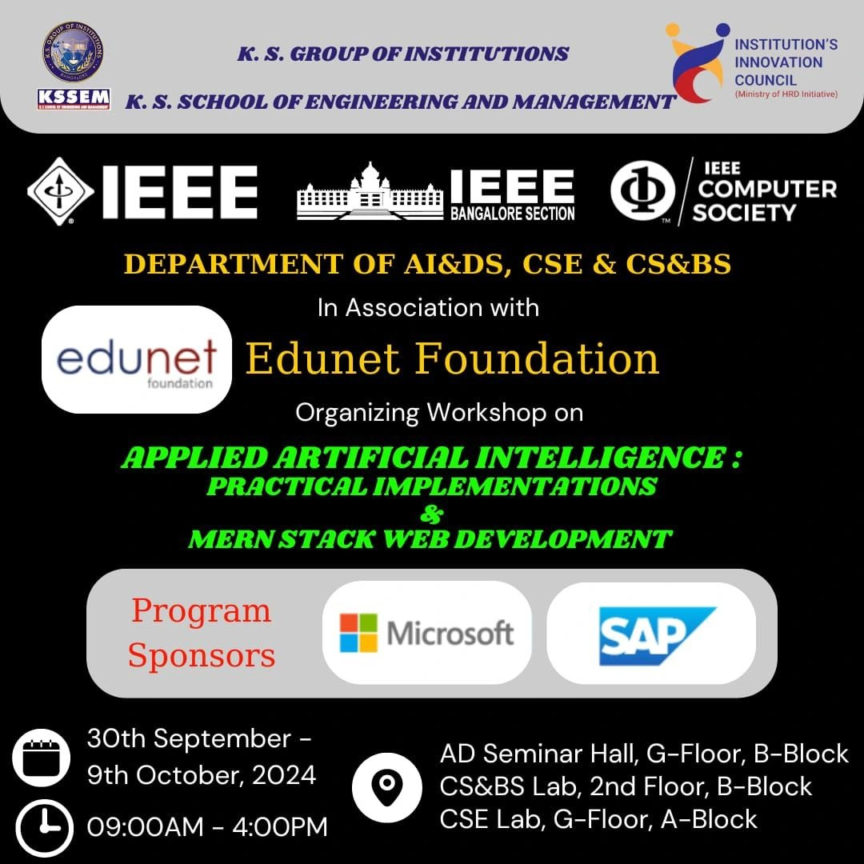
* **APPLIED ARTIFICIAL INTELLIGENCE: PRACTICAL IMPLEMENTATION & MERN STACK WEB DEVELOPMENT**
* "Department of Computer Science an Business system organized 10 days workshop program to 5th semester students on Applied Artificial Intelligence: Practical Implementations and Mern Stack Web development in association with Edunet Foundation and SAP. The event took place from September 30 to October 9, 2024, and aimed to equip students with the skills to create AI-driven web applications"
* 2024-09-30
* 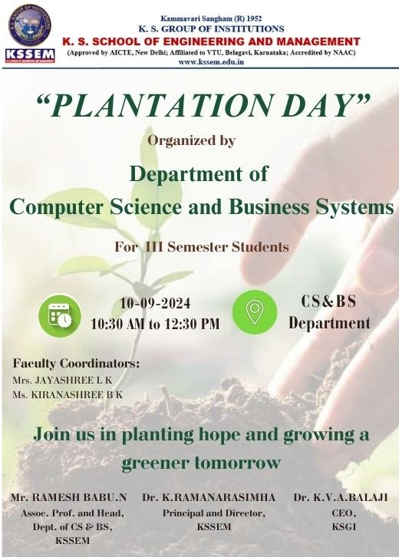
* **SCR ACTIVITY: TREE PLANTATION**
* "The Department of Computer Science and Business Systems department organized a Plantation Day on 10/09/2024 for 3rd semester students. It was as a part of SCR activity. Students planted tree in the campus. They also explained the history, significance and uses of the plant in daily life."
* 2024-09-10
* 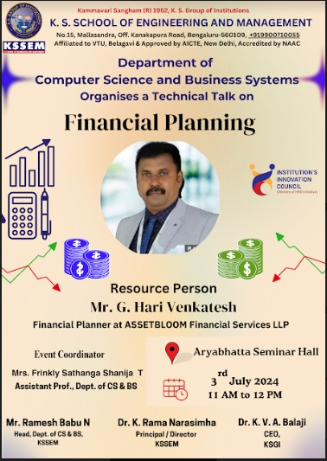
* **FINANCIAL PLANNING**
* "Department of Computer Science and Business Systems organized a technical talk on "Financial Planning" for 4th semester students on 03/07/2024. Mr. G. Hari Venkatesh, is a renowned financial planner with expertise in helping individuals and organizations navigate complex financial landscapes. His talk covered essential principles and strategies for building a solid financial foundation."
* 2024-07-03
* 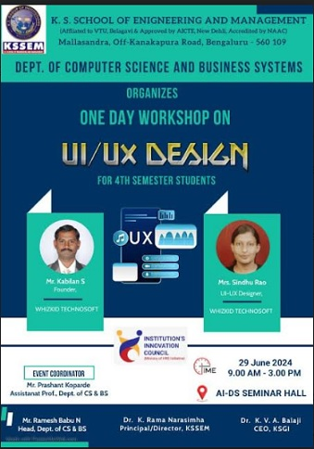
* **ONE DAY WORKSHOP ON UI/UX DESIGN**
* "The Computer Science and Business Systems had organized One Day Workshop on "UI/UX DESIGN" for 4th semester students on 29/06/2024. Mr. Kabilan S, Founder, Whizkid Technosoft, Bengaluru and Mrs. Sindhu Rao, UI/UX Designer, Whizkid Technosoft, Bengaluru were the resource persons."
* 2024-06-29
* 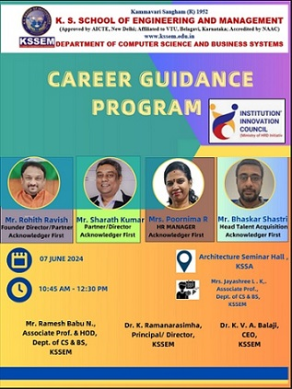
* **CAREER GUIDANCE PROGRAM**
* "Department of Computer Science and Business Systems organized a "Career Guidance Program" for 4th semester students on 07/06/2024. Mrs. Poornima R HR Manager of Acknowledger First initiated the session explaining about present requirements in the market. She also explained about how to meet those requirements and what are all the companies looking for technology. "
* 2024-06-07
* 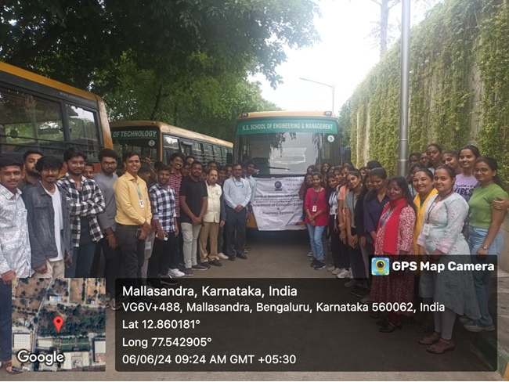
* **INDUSTRIAL VISIT TO ISRO**
* "Department of Computer Science and Business systems organized an Industrial Visit to U. R. Rao Satellite Centre (URSC), ISRO Bengaluru on 06/06/2024 for 4th semester students. The URSC is centre of Indian Space Program. It has developed satellites for advanced communication, meteorological, remote sensing, navigation and space science. The space science missions like Chandrayaan -3, Mars Orbiter Mission and Astrosat have received world-wide acclaim and put India in the global map."
* 2024-06-06
* 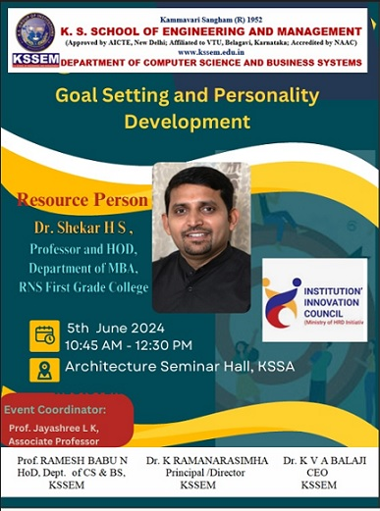
* **GOAL SETTING AND PERSONALITY DEVELOPMENT**
* "Department of Computer Science and Business Systems organized a seminar on "Goal Setting and Personality Development" on 05/06/2024. Dr. Shekar H S Prof. and HOD for Department of MBA from RNS First Grade College took this special session and guided 2nd and 4th semester students from CS & BS Department. "
* 2024-06-05
* 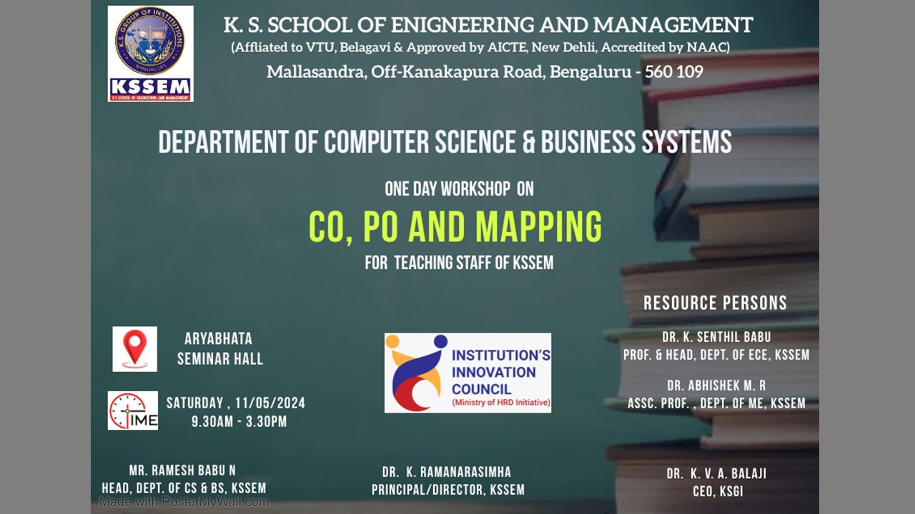
* **ONE DAY WORKSHOP ON CO, PO & MAPPING**
* "The Computer Science and Business Systems had organized One Day Workshop on "CO, PO and Mapping" for the teaching staff of KSSEM on 11/05/2024. Dr. K Senthil Babu, Professor and Head, Department of Electronics and Communication Engineering, KSSEM, and Dr. Abhishek R, Associate Professor, Department of Mechanical Engineering, KSSEM were the resource persons."
* 2024-05-11
* 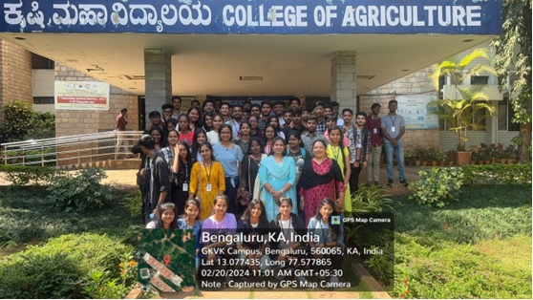
* **SCR ACTIVITY VISIT TO GKVK CAMPUS**
* " 3rd semester students of Department of Computer Science and Business Systems visited the University of Agriculture Sciences, GKVK campus, Bengaluru on 20/02/2024 as part of the co-curricular activities for the subject Social Connect and Responsibility."
* 2024-02-20
* 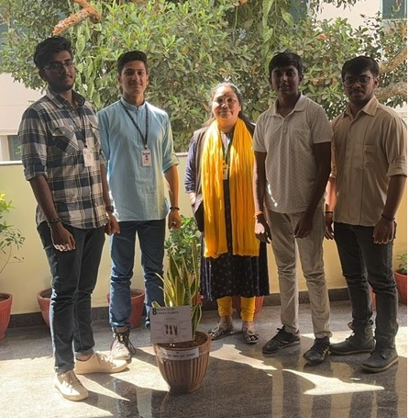
* **SCR ACTIVITY: TREE PLANTATION**
* "The Department of Computer Science and Business Systems department organized a Plantation Day on 16/02/2024 for 3rd semester students. It was as a part of SCR activity. Students planted tree in the campus. They also explained the history, significance and uses of the plant in daily life."
* 2024-02-16
* 
* **SCR ACTIVITY: FOOD WALK**
* "The Department of Computer Science and Business Systems department organized a FOOD-WALK on 16/02/2024 for 3rd semester students. It was as a part of SCR activity where students had to study about particular food, its ingredients, significance and health benefits."
* 2024-02-16
* 
* **TECHNICAL TALK ON MACHINE LEARNING AND DATA SCIENCE**
* "The Department of Computer Science and Business Systems department organized a Technical Talk on "Machine Learning and Data Science" on 10/02/2024 for 3rd semester students. The session was arranged to introduce the future job opportunities in the Machine Learning and Data Science and how students can start preparing to acquire skills enough to compete. Mr. Vinay M. Harista, Technical Director and Co-Founder, Vtricks Technologies was the resource person. "
* 2024-02-10
* 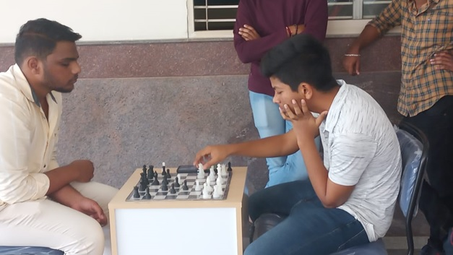
* **Sports Meet 2024**
* "The Department of Computer Science and Business Systems conducted Annual Meet on 01/02/2024 jointly with department of Computer Science and Engineering for the students of CSE and CS & BS."
* 2024-02-01
* 
* **Springboard Workshop**
* "The 3rd semester students of Computer Science and Business Systems department attended Three Day Student Enablement Program (SEP) on Artificial Intelligence using Infosys Springboard platform from 23/01/2024 to 25/01/2024 organized by Infosys."
* 2024-01-25
* 
* **Inauguration of New Department Block**
* "Inauguration of new Department Block, Department of Computer Science and Business Systems was conducted on 23/01/2024."
* 2024-01-23
* 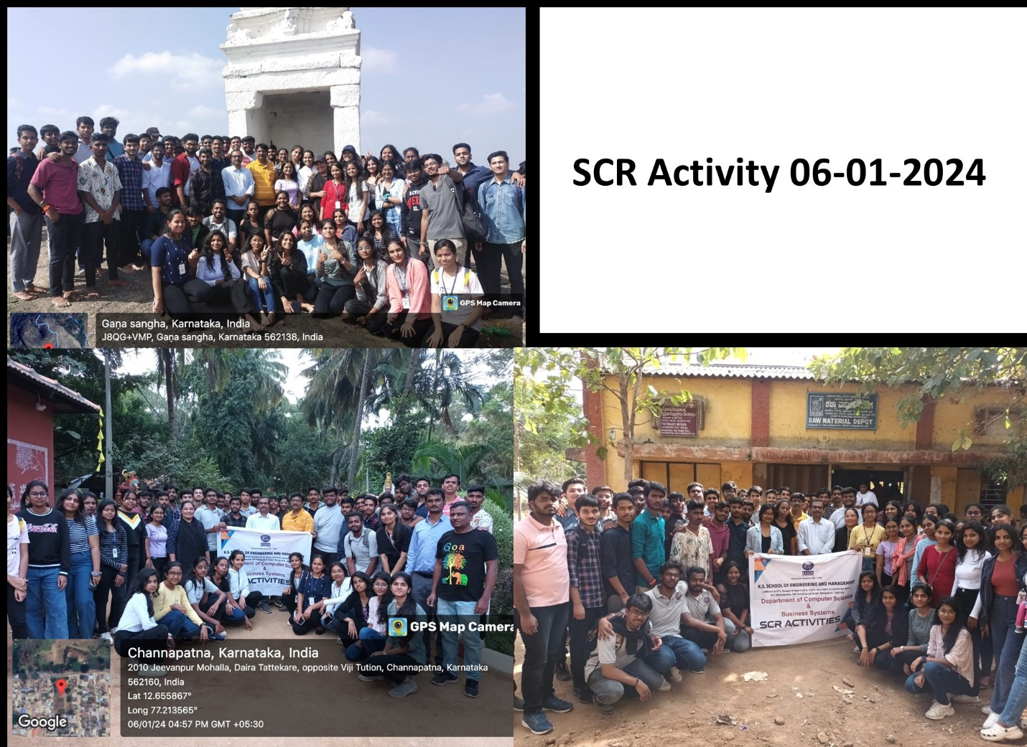
* **SCR Activity**
* "Visited SRS Betta, Channapatna Toy Factory and Janapadaloka in align with Social Connect and Responsibility on 06-01-2024."
* 2024-01-06
* **E-resources**
* A large number of Electronic Resources are available for all the subjects.
* All the users of library resources of KSSEM must adhere to copyright laws of publishers and consortia.
* No copyrighted work may be copied, published, disseminated, displayed, performed, without permission of the copyright holder except in accordance with fair use or licensed agreement. This includes DVDs/CDs and other copyrighted material. Using these resources for commercial purpose, systematic downloading, copying or distributing of information is prohibited. KSSEM may terminate the online access of users who are found to have infringed copyright.

**MOUs Signed**

**The Memorandum of Understanding details modalities and general conditions regarding collaboration between the INDUSTRY and KSSEM. Also facilititate for enhancing and encouraging students for interactions between the Industry Experts, Scientists, Research fellows and Faculty members for knowledge sharing with the following objectives:-**

* **Collaboration in conduction of conferences, workshops, seminars and hackthons.**
* **Provides industry exposure to KSSEM students.**
* **Mutually agreed guidance for student's projects and scholar's reserarch works through internship and industrial training.**
* **Provision given for the usage of institute infrastructure by industry like library, internet and computational facilities etc.**

**Pygenicarc**[**[view here]**](https://kssem.edu.in/images/1742441248038_image.pdf)

**Vtricks Technologies**[**[view here]**](https://kssem.edu.in/images/1742441099062_image.pdf)

**Social Activities**

**Teaching Learning and growing Together. Empowering Young Minds about the higher Technical and Vocational Education with our NSS Student of CS & BS Department at GHPS Bayanapalya Government School. Near KSSEM, Mallasandra , Bengaluru**[**[view here]**](https://kssem.edu.in/images/1720409053980_image.gif)

**Chandan and Kamal Sai Participated in NSS ACTIVITY @ Virupakshipuram organized by KSSEM**[**[view here]**](https://kssem.edu.in/images/1712213017156_image.gif)